**Unit I**

**Operating Systems:**

An Operating System acts as a communication interface between the user and computer hardware. The purpose of an operating system is to provide a platform on which a user can execute programs in a convenient and efficient manner.

An operating system is a piece of software that manages the allocation of computer hardware. The coordination of the hardware must be appropriate to ensure the correct working of the computer system and to prevent user programs from interfering with the proper working of the system. The main task an operating system carries out is the allocation of resources and services, such as allocation of: memory, devices, processors and information. The operating system also includes programs to manage these resources, such as a traffic controller, a scheduler, memory management module, I/O programs, and a file system.

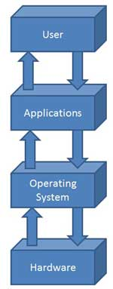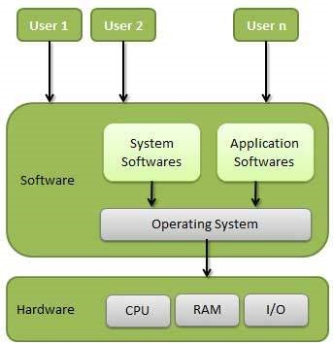

**Objectives of Operating System**

The objectives of the operating system are −

* To make the computer system convenient to use in an efficient manner.
* To hide the details of the hardware resources from the users.
* To provide users a convenient interface to use the computer system.
* To act as an intermediary between the hardware and its users, making it easier for the users to access and use other resources.
* To manage the resources of a computer system.
* To keep track of who is using which resource, granting resource requests, and mediating conflicting requests from different programs and users.
* To provide efficient and fair sharing of resources among users and programs.

**Functions of Operating Systems:**

* **Security –** The operating system uses password protection to protect user data and similar other techniques. it also prevents unauthorized access to programs and user data.
* **Control over system performance –** Monitors overall system health to help improve performance. records the response time between service requests and system response to have a complete view of the system health. This can help improve performance by providing important information needed to troubleshoot problems.
* **Job accounting –** Operating system Keeps track of time and resources used by various tasks and users, this information can be used to track resource usage for a particular user or group of user.
* **Error detecting aids –** Operating system constantly monitors the system to detect errors and avoid the malfunctioning of computer system.
* **Coordination between other software and users –** Operating systems also coordinate and assign interpreters, compilers, assemblers and other software to the various users of the computer systems.
* **Memory Management –** The operating system manages the Primary Memory or Main Memory. Main memory is made up of a large array of bytes or words where each byte or word is assigned a certain address. Main memory is a fast storage and it can be accessed directly by the CPU. For a program to be executed, it should be first loaded in the main memory. An Operating System performs the following activities for memory management:
* **Processor Management –** In a multi programming environment, the OS decides the order in which processes have access to the processor, and how much processing time each process has. This function of OS is called process scheduling. An Operating System performs the following activities for processor management.
* **Device Management –** An OS manages device communication via their respective drivers. It performs the following activities for device management. Keeps tracks of all devices connected to system. designates a program responsible for every device known as the Input / Output controller. Decides which process gets access to a certain device and for how long. Allocates devices in an effective and efficient way. Deallocates devices when they are no longer required.
* **File Management –** A file system is organized into directories for efficient or easy navigation and usage. These directories may contain other directories and other files. An Operating System carries out the following file management activities. It keeps track of where information is stored, user access settings and status of every file and more… These facilities are collectively known as the file system.